WorkHorse Z-Axis Mount Dimensions
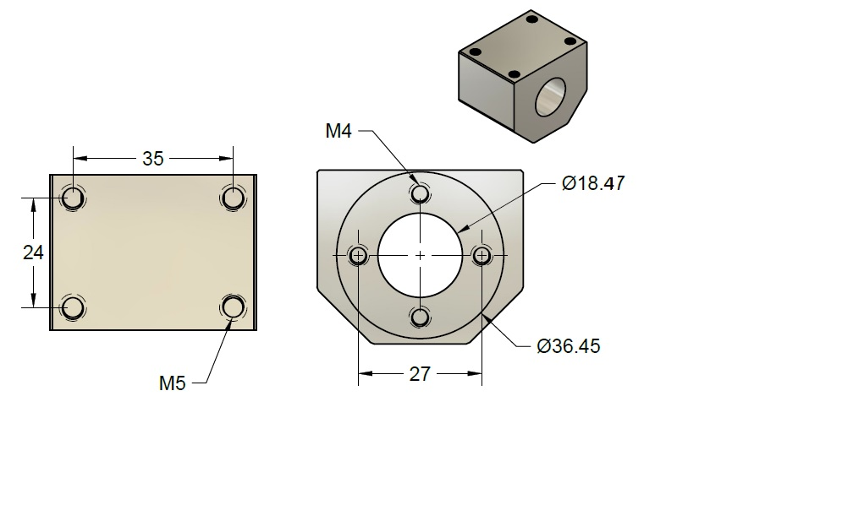
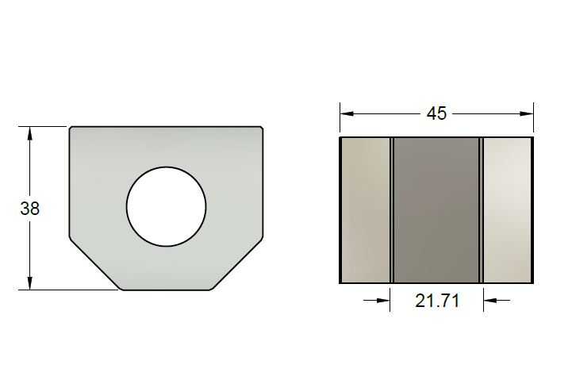

Z-Axis Lead Screw Nut Mount
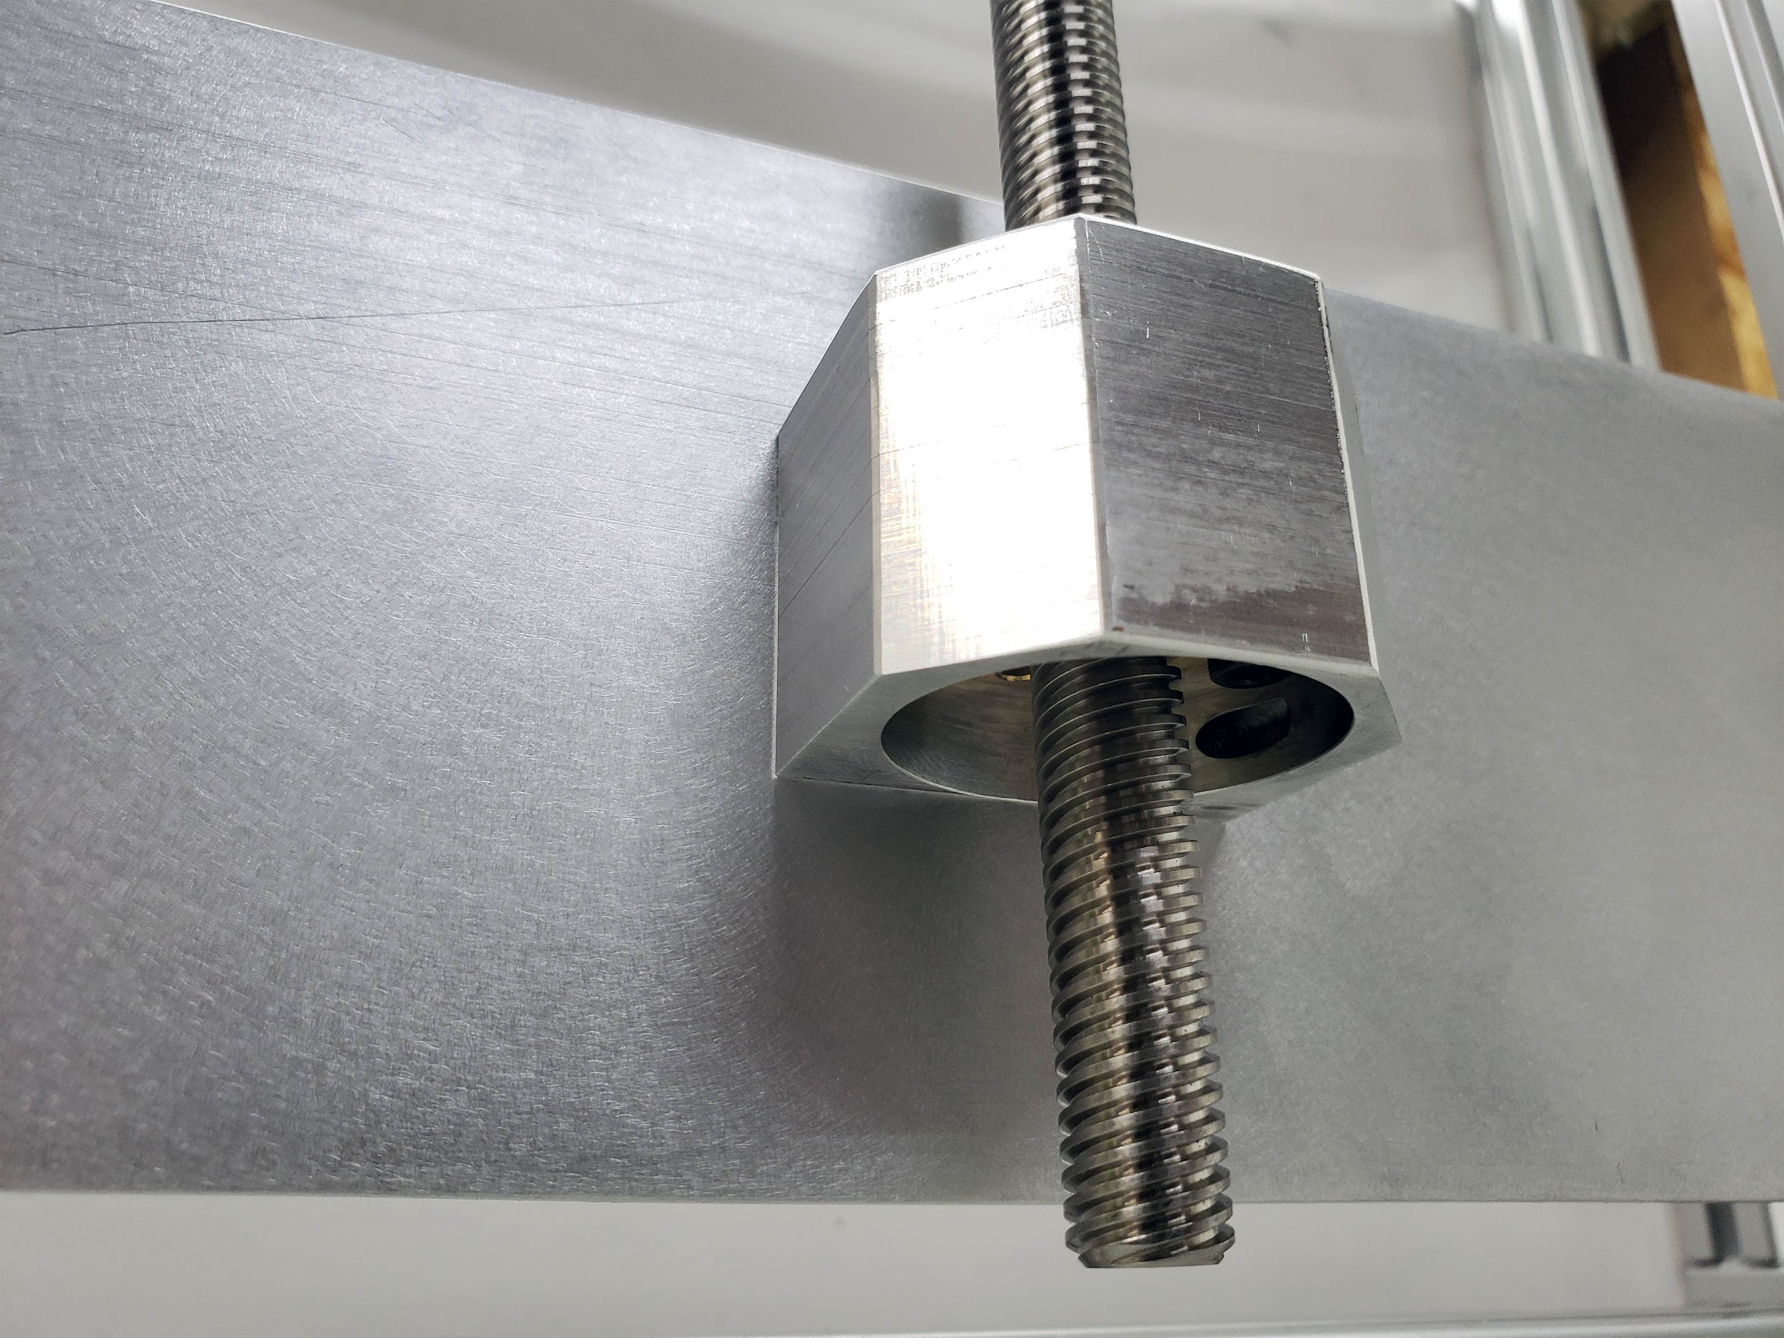

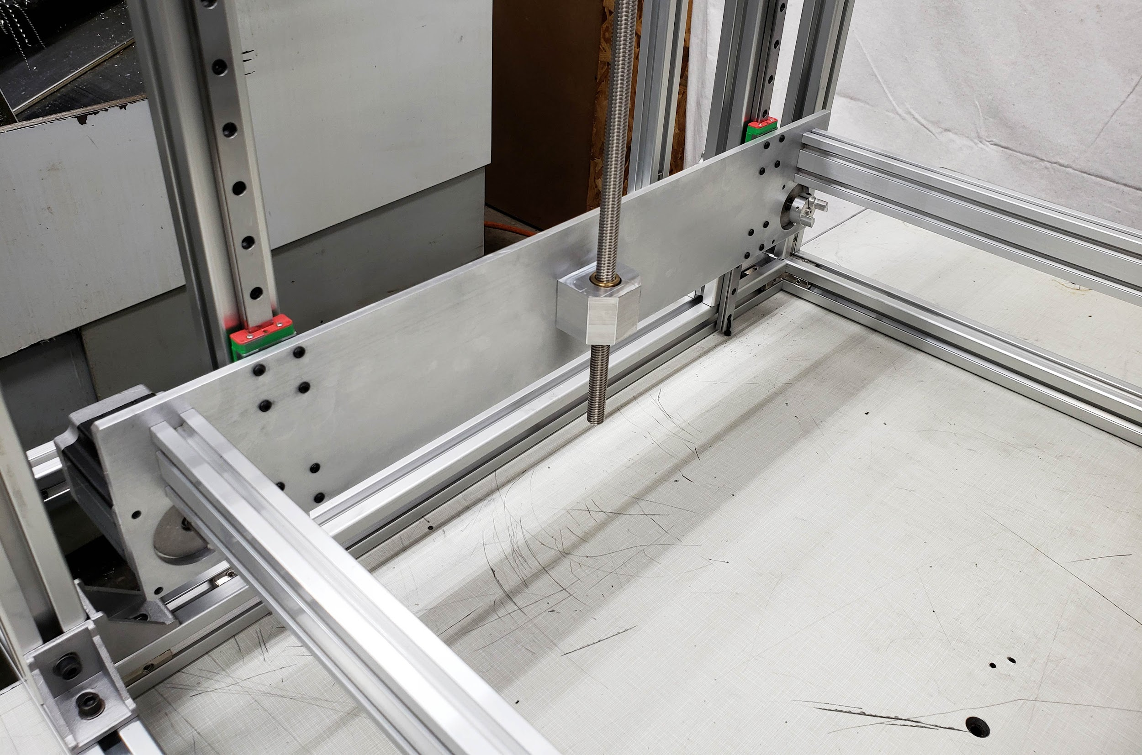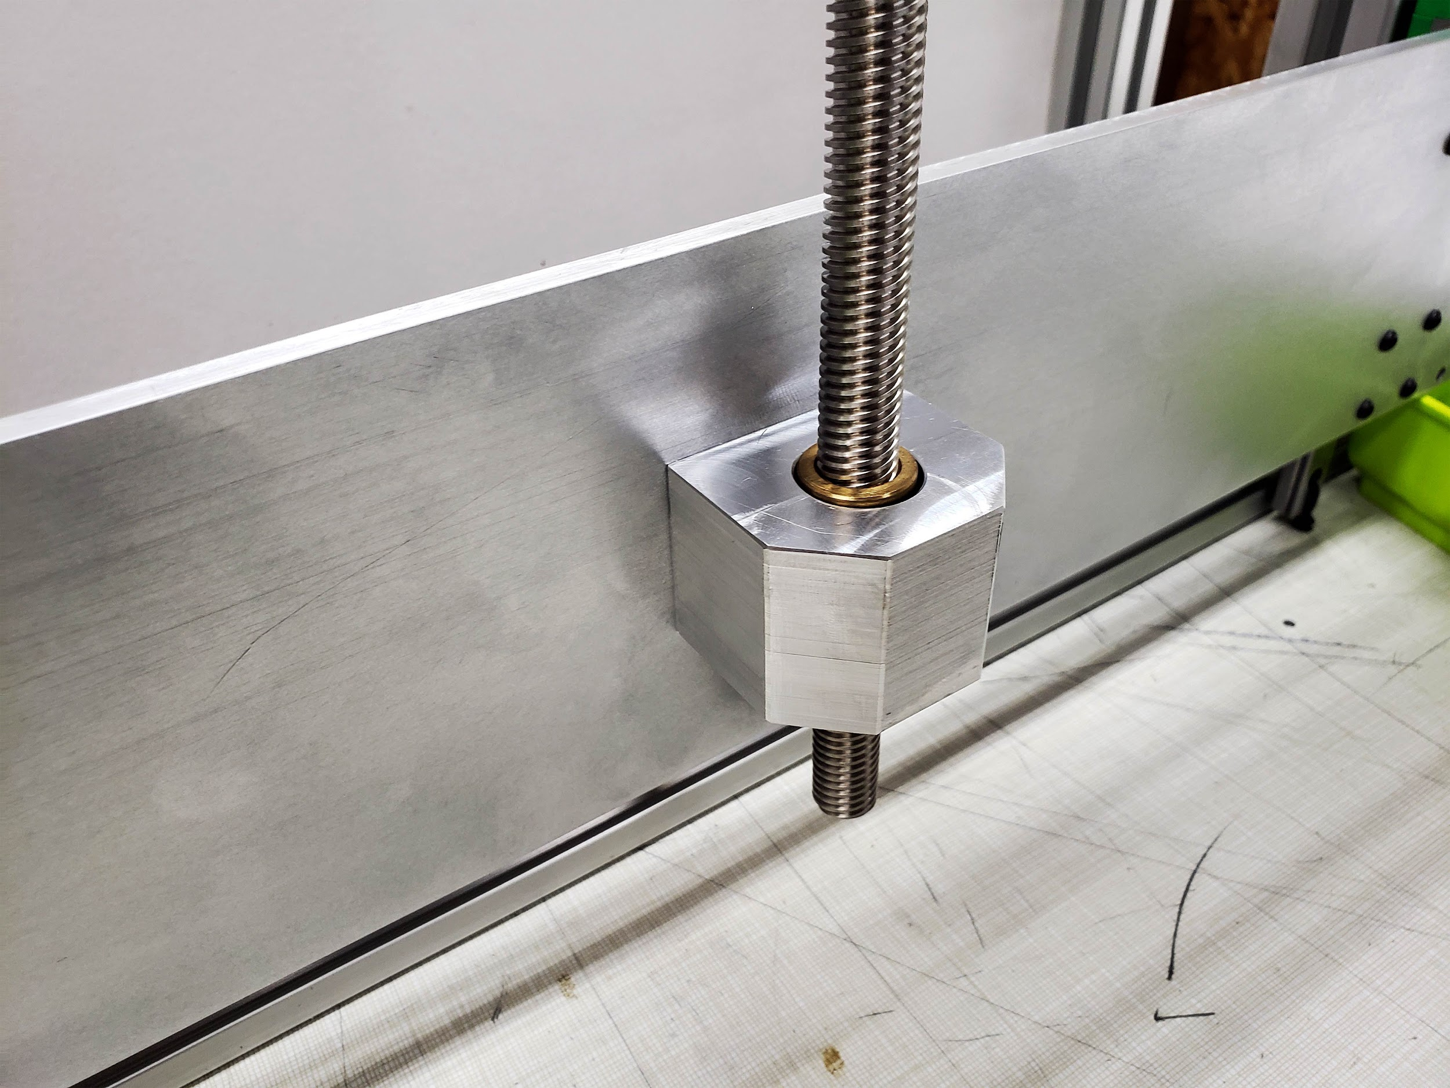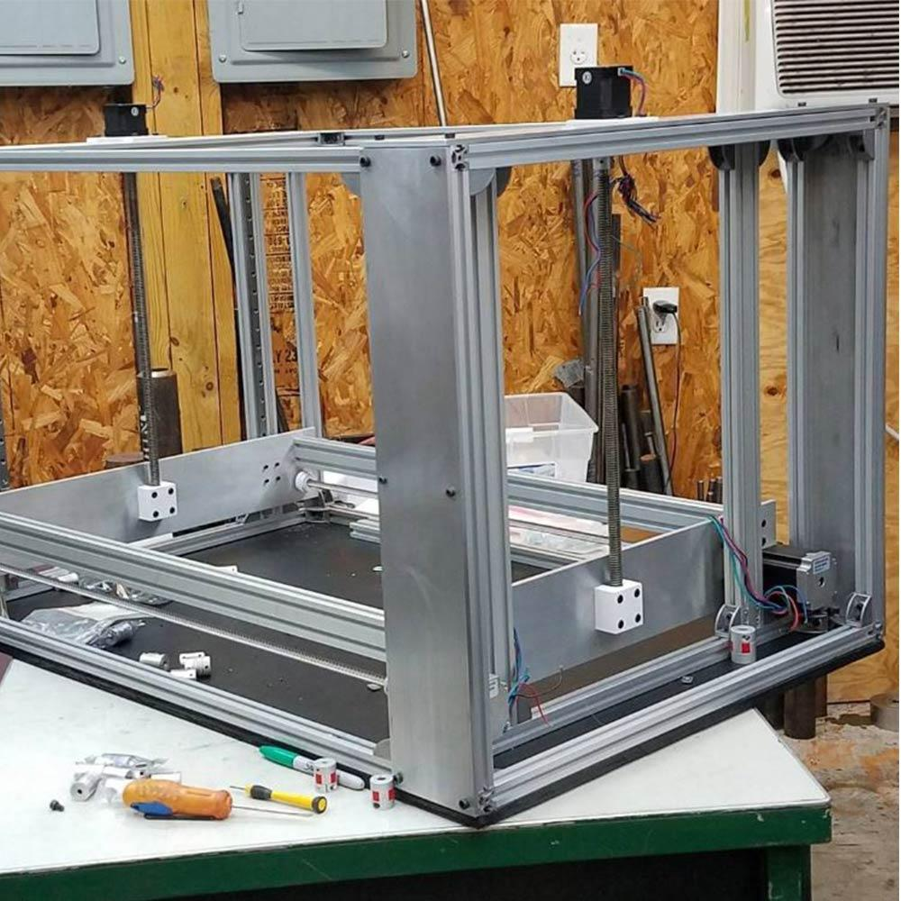

Related Content
Workhorse 3D Printer
Workhorse 3D Printer CAD
3D Distributed
WorkHorse Documentation
WorkHorse BOM

